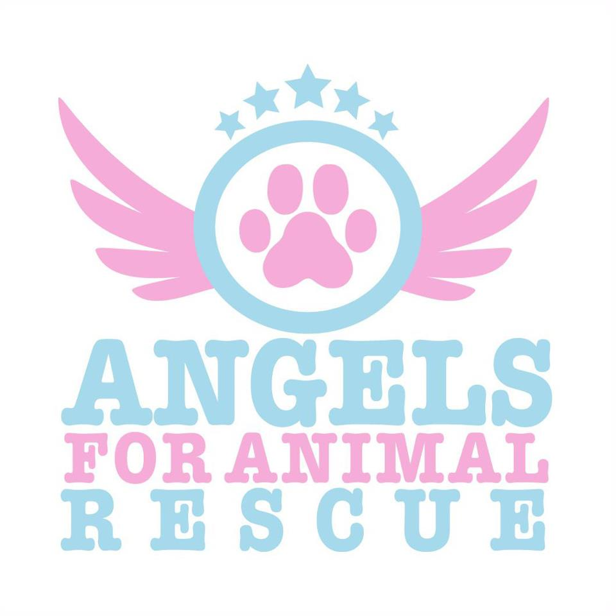

angelsforanimalrescue@hotmail.com
Cat Adoption Agreement
Adoption Date: Cat Name: Foster Parent:
Cat Age: Breed: Color: M/F

In adopting my cat, I agree to the following:

- I have not falsified any information on the adoption application and understand that it is incorporated into this Agreement.
- I do not live in nor will I move to a building or community whose restrictions on the number, breed or size of pets interfere with my fulfilling my commitment to this cat.
- I will provide a safe and loving home for my cat. My cat is being adopted as a family cat and as such will be restricted inside the house.
- I will provide my cat with proper food, water, shelter, training, exercise, attention, and medical treatment as necessary. I will provide lifetime care, including annual Veterinary exams and booster shots, and immediate medical attention when necessary.
- I will provide cat with a collar and ID tag to be worn at all. I will not let my cat run free. I will ensure my cat can not escape from my yard or home. I will not chain or tie my cat up to secure him.
- I will NOT have my cat adopted declawed.
- If I can no longer provide adequate care for my cat, I agree and commit to return my cat directly to Angels for Animal Rescue Inc. I understand that to the best of Angels for Animal Rescue’s knowledge, the cat I am adopting is in good health (unless problems are specified) and that I have been provided such health records as Angels For Animal Rescue has for this cat. I will not hold Angels for Animal Rescue liable for any future medical bills my cat may incur.
- I will not euthanize my cat unless my cat’s health is beyond reasonable medical assistance. I further understand that medical care for a cat can be costly, especially as my cat ages. I agree to make adequate and reasonable efforts to attend to my cat’s medical needs, and I will not euthanize my cat just because I do not want to incur the medical expense.
- I understand that Angels for Animal Rescue Inc. is not responsible for the behavior of my cat once delivered into my possession. I also understand that cat, especially untrained kittens can cause expensive damage to carpets, furniture, and other personal belongings and I agree to work with my cat and train him to prevent such undesirable behavior. I assume full responsibility for my cat’s actions and recognize that Angels for Animal Rescue Inc. is not liable for any damage that may occur from the time of adoption forward.
- I understand that although every effort has been made to evaluate the temperament of my cat, it is impossible to assess each cat in every situation. I understand that cats may act dramatically different under stressful circumstances (such as storms, holiday fireworks, strangers, other aggressive cats). I also understand that all cats, by being animals, are never 100% predictable: any cat is capable of biting or scratching and Angels for Animal Rescue inc. is not responsible should this cat do so.
- I understand that donations are not refundable.
- I will keep Angels for Animal Rescue apprised of my current address while I have my cat.
- I will contact Angels for Animal Rescue immediately should my cat get lost.
- I understand that Angels for Animal Rescue Inc. may contact me to check on my cat’s safety, living conditions, health or well-being. Angels for Animal Rescue Inc. reserves the right to reclaim the cat at once should it learn that any of the foregoing is unsatisfactory.

I have read and consent to all of the above. I understand this contract is legally binding and if there is any breach of its terms Angels for Animal Rescue Inc. can reclaim my pet with no refund of the adoption. If I fail to surrender my pet under such circumstances I will be required to pay liquidated damages of $500 plus attorney fees and costs.

Signature of Adopter: _____________________________ Date: _________ Donation Amt $________
Name: Address:
City, State, Zip: CA Driver’s License #:
Phone (Day): Phone (Eve):

Phone (Cell): Email:

