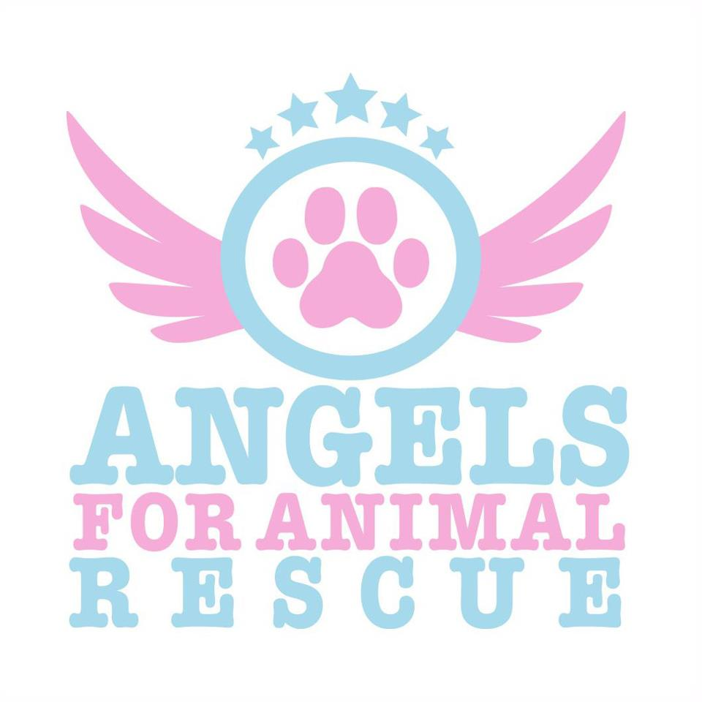

angelsforanimalrescue@hotmail.com
Dog Adoption Agreement
Adoption Date: Dog’s Name: Foster Parent:
Dog’s Age: Breed: Color: M/F SH MH LH

In adopting my dog, I agree to the following:

- I have not falsified any information on the adoption application and understand that it is incorporated into this Agreement.
- I do not live in nor will I move to a building or community whose restrictions on the number, breed or size of pets interfere with my fulfilling my commitment to this dog.
- I will provide a safe and loving home for my dog. My dog is being adopted as a family dog and as such will NOT be restricted primarily to the yard and will sleep inside the house at night.
- I will provide my dog with proper food, water, shelter, training, exercise, attention, and medical treatment as necessary. I will provide lifetime care, including annual Veterinary exams and booster shots, and immediate medical attention when necessary.
- I will provide my dog with a collar and ID tag to be worn at all times I will not leave training leads (choke collars) on my dog when my dog is alone. I will not let my dog run free. When outdoors my dog will either be kept in a secure fenced yard or kennel run, or on a leash when in an open/public area. I will ensure my dog can not escape from my yard or home. I will not chain or tie my dog up to secure him.
- If I can no longer provide adequate care for my dog, I agree and commit to return my dog directly to Angels for Animal Rescue Inc. I understand that to the best of Angels for Animal Rescue Inc.’s knowledge, the dog I am adopting is in good health (unless problems are specified) and that I have been provided such health records as Angels for Animal Rescue Inc. for this dog. I will not hold Angels for Animal Rescue Inc liable for any future medical bills my dog may incur.
- I will not euthanize my dog unless my dog’s health is beyond reasonable medical assistance. I further understand that medical care for a dog can be costly, especially as my dog ages. I agree to make adequate and reasonable efforts to attend to my dog’s medical needs, and I will not euthanize my dog just because I do not want to incur the medical expense.
- I understand that Angels for Animal Rescue Inc. is not responsible for the behavior of my dog once delivered into my possession. I also understand that dogs, especially untrained puppies, can cause expensive damage to carpets, furniture, and other personal belongings and I agree to work with my dog and train him to prevent such undesirable behavior. I assume full responsibility for my dog’s actions and recognize that Angels for Animal Rescue Inc. is not liable for any damage that may occur from the time of adoption forward.
- I understand that although every effort has been made to evaluate the temperament of my dog, it is impossible to assess each dog in every situation. I understand that dogs may act dramatically different under stressful circumstances (such as storms, holiday fireworks, strangers, other aggressive dogs). I also understand that all dogs, by being animals, are never 100% predictable: any dog is capable of biting and or scratching and Angels for Animal Rescue Inc. is not responsible should this dog do so.
- Adoption fees are non-refundable and I will keep Angels for Animal Rescue Inc. apprised of my current address while I have my dog.
- I will contact Angels for Animal Rescue Inc. immediately should my dog get lost.
- I understand that Angels for Animal Rescue Inc. may contact me to check on my dog’s safety, living conditions, health or well-being. Angels for Animal Rescue Inc. reserves the right to reclaim the dog at once should it learn that any of the foregoing is unsatisfactory.

I have read and consent to all of the above. I understand this contract is legally binding and if there is any breach of its terms Angels for Animal Rescue Inc. can reclaim my pet with no refund of the adoption. If I fail to surrender my pet under such circumstances I will be required to pay liquidated damages of $500 plus attorney fees and costs.

Signature of Adopter: _____________________________ Date: _________ Donation Amt $________
Name: Address:
City, State, Zip: CA Driver’s License #:
Phone (Day): Phone (Eve):

Phone (Cell): Email:

